You are given an m x n integer matrix matrix with the following two properties:

* Each row is sorted in non-decreasing order.
* The first integer of each row is greater than the last integer of the previous row.

Given an integer target, return true *if* target *is in* matrix *or* false *otherwise*.

You must write a solution in O(log(m * n)) time complexity.

**Example 1:**

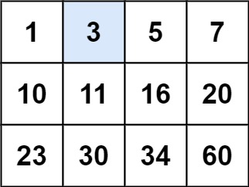

Input: matrix = [[1,3,5,7],[10,11,16,20],[23,30,34,60]], target = 3  
Output: true

**Example 2:**

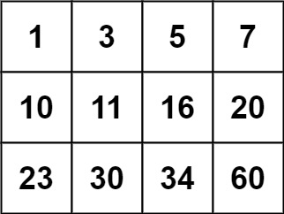

Input: matrix = [[1,3,5,7],[10,11,16,20],[23,30,34,60]], target = 13  
Output: false

**Constraints:**

* m == matrix.length
* n == matrix[i].length
* 1 <= m, n <= 100
* -104 <= matrix[i][j], target <= 104